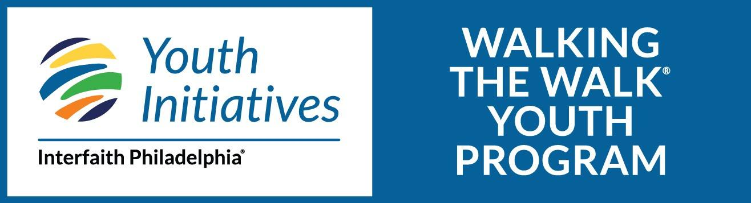

Walking the Walk 2022-2023 *Draft Calendar*
High School Dates  *note: high school students may need to attend sessions in the Spring listed on the middle school side for the facilitation portion of their leadership training | Middle School Dates
September 18, 2022  October 2, 2022  October 23, 2022  November 6, 2022  November 20, 2022  December 4, 2022  December 18, 2022  January 15/16, 2023 – MLK Day of Service  February 12, 2023  March 12, 2023  April 16, 2023  May 21, 2023 – End of Year Celebration | September 18, 2022  October 23, 2022  November 20, 2022  December 18, 2022  January 15/16, 2023 – MLK Day of Service  January 29, 2023 -  February 12, 2023  February 26, 2023  March 12, 2023  March 26, 2023  April 16, 2023  May 7, 2023  May 21, 2023 – End of Year Celebration
*Please note: dates may change, and sessions may move to a virtual setting pending pandemic safety concerns and regulations. Sessions will always take place on Sundays from 2pm-4:30pm*

