Journeying and Pilgrimage in the Bahá'í Faith

With pleasure and joy, the Bahá'í community of Philadelphia and vicinity invites you to share a brief reflection on the meaning of journeying and of pilgrimage in the Bahá'í Faith.

We offer thoughts on seven themes that infuse Bahá'í spirituality, practice, and history:

- The soul’s journey
- The exiles of Bahá'u'lláh
- Journeys of His followers to see Him
- Ordinances of pilgrimage for all believers
- Travels of ‘Abdu’l-Bahá
- Walking a path of service
- A place of pilgrimage in Philadelphia

In addition, you can find information about the Philadelphia Bahá'í Center, part of the Virtual Pilgrimage route, at the end of this document.

First, a word about the Central Figures of the Bahá'í Faith, from Whose lives and teachings these themes proceed. Bahá'ís are followers of Bahá'u'lláh (in English, “The Glory of God”), Who, we believe, is the Promised One of all ages. The traditions of many peoples and the teachings of many Faiths promise a future when the peace, harmony, and prosperity of humankind will be established. Bahá'ís believe the promised hour has come and that Bahá'u'lláh is that great Personage Whose teachings will enable humanity to build a new world.

In Bahá'í belief, Bahá'u'lláh was actually the second, and the greater, of two Messengers of God Whose lives overlapped. The earlier Messenger, Who took the title “The Báb” (the Gate), both announced the coming of the Promised One and founded an independent religion.

The third of the Central Figures was ‘Abdu’l-Bahá (Servant of Bahá). By birth, He was the son of Bahá'u'lláh; by station, He was named by Bahá'u'lláh as the Center of the Covenant – to Him all Bahá'ís were to turn for guidance. He was the appointed Interpreter and Exemplar of Bahá'u'lláh’s teachings and the head of the Faith after Bahá'u'lláh’s passing.
More detail about each of Their lives can be found at:
https://www.bahai.org/beliefs/bahaullah-covenant

The Soul’s Journey
According to Bahá'í teachings, the true human self is soul, not body. Bahá'u'lláh affirmed the reality of an eternal spiritual life which continues after our physical death. As in other traditions, Bahá'í teachings compare our life in the physical world to a journey.

Bahá'u'lláh refers to the search for God in terms of a “path leading to the knowledge of the Ancient of Days” and describes the ideal spiritual conditions for traveling this path.
We should mention that translations of Bahá'í Scripture use the pronouns “he” “him” and “his” to refer to the Deity. This is a convenience and a convention; Bahá'í teachings do not ascribe gender to God, Whose nature is not material. These same pronouns are often used to refer to the human being of any gender; it is understood as such by Bahá'ís. (Gender discrimination is prohibited in Bahá'í teachings.) Here is the path of the true seeker:
https://www.bahai.org/library/authoritative-texts/bahaullah/gleanings-writings-bahaullah/7#186611355

In an essay written for a gentleman who was both a scholar and a mystic, Bahá'u'lláh used a metaphor familiar in the Sufi tradition:
“…the stages that mark the wayfarers’ journey from their mortal abode to the heavenly homeland are said to be seven. Some have referred to them as seven valleys, and others, as seven cities.” The entire treatise, known in English as The Seven Valleys, is remarkable for the beauty and power of its mystical language. It can be accessed here:
https://www.bahai.org/library/authoritative-texts/bahaullah/call-divine-beloved/3#192383421

Bahá'u'lláh wrote that every soul will “return” to God: “Know thou that every hearing ear, if kept pure and undefiled, must, at all times and from every direction, hearken to the voice that uttereth these holy words: ‘Verily, we are God’s, and to Him shall we return.’ The mysteries of man’s physical death and of his return have not been divulged, and still remain unread.”
https://www.bahai.org/library/authoritative-texts/bahaullah/gleanings-writings-bahaullah/8#256414695

Bahá'í teachings assert that the relatively brief period of our physical existence is for our education and development: we are here to learn and to develop “perfections,” or in other words, spiritual qualities. Spiritual qualities will be our main provision for life in the world to come.

In the following excerpt from the works of ‘Abdu’l-Bahá', physical life is explicitly compared to a journey:
“…The human spirit is a divine trust which must traverse every degree, for traversing and passing through the degrees of existence is the means of its acquiring perfections. So, for example, when a man travels in an orderly and methodical manner through many different countries and regions, this will most certainly be the means of acquiring perfections…”
The full passage is here:
https://www.bahai.org/library/authoritative-texts/abdul-baha/some-answered-questions/10#074630127

The Messenger of God in Exile
Bahá'u'lláh spent nearly 40 years of His life in exile from His native Persia (present-day Irán). At age 35, wrongly accused of plotting to assassinate the Sháh, He was banished to Baghdád in the Ottoman Empire. There, His profound wisdom, His loving nature, His majestic and magnetic presence, earned Him the esteem and love of high and low alike, from religious leaders to poets and mystics to government officials and ordinary citizens. His growing following alarmed the established religious and secular officials, who feared losing their hold on power. As a result, the authorities extended his banishment first to Constantinople (Istanbúl), then Adrianople (Edirne), and finally to ‘Akká (present-day Akko) in what is now the State of Israel. In each city, He was confined to prison. The harsh conditions of His imprisonment are a separate story. His earthly life ended in ‘Akká in 1892.
Wandering, banishment, exile, and suffering have often been the fate of the Messengers of God. Examples include the flight of the Holy Family of Jesus into Egypt; His life in which He had “nowhere to lay His head” (Matthew 8:20); the sudden migration of the Prophet Muhammad from Mecca to Medina; the Exodus of Moses and the children of Israel from Egypt; and the wanderings of the Buddha in search of enlightenment. Notably, ‘Abdu’l-Bahá draws a parallel between Bahá'u'lláh’s banishment and that of Abraham. He notes the far-reaching consequences of the latter and suggests that the former is equally monumental:
https://www.bahai.org/library/authoritative-texts/abdul-baha/some-answered-questions/4#276266411
Here is a map of Bahá'u'lláh’s successive places of exile:

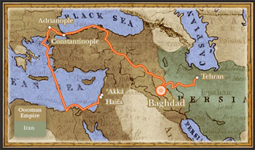

Journeying and Pilgrimage in Bahá'u'lláh’s lifetime
To whatever place Bahá'u'lláh was banished, He inspired such love and devotion that His followers always found their way to Him, sometimes traveling hundreds of miles on foot. The dearest wish of the believers was to be in His presence, which for them was as close as they could come to the Presence of the Divine Being. Myriad tales recount the hardships endured by these early pilgrims and their joy upon reaching their goal.

For just one example, early in Bahá'u'lláh’s confinement to a barracks in the Ottoman prison-city of ‘Akká, Bahá'í travelers had no access to Him; yet they made their way to the city and would stand across the moat surrounding the prison, staring at the window of his quarters in hope of a glimpse of His face.
https://www.bahai.org/library/authoritative-texts/shoghi-effendi/god-passes-by/13#300935094

For His part, Bahá'u'lláh often conferred on these travelers a mission. As He was deprived of freedom of action, He had to communicate with others through trusted emissaries. These individuals left home and family for months on end, traveling back and forth many times to and from the various prisons. They carried letters to the believers in various lands and sometimes to religious and government officials. In these letters, Bahá'u'lláh repeatedly called upon the population to recognize His coming as the Promised One, and He expounded the teachings of God. In this way the Bahá'í Faith was spread in its early days.
Here is an account of one such emissary:
https://www.bahai.org/library/authoritative-texts/abdul-baha/memorials-faithful/2#253954381

After His passing in 1892, His resting place near ‘Akká became the focus of pilgrimage, as it remains to this day.

The Ordinances of Pilgrimage
The Bahá'í scriptures set forth a religious law of pilgrimage. Bahá'u'lláh ordained pilgrimage once in an individual’s lifetime, for those who can afford it. His intention was that the goal of pilgrimage be one of two houses regarded as holy: the House of The Báb in Shiráz, Irán, or the House of Bahá'u'lláh in Baghdád, Iraq. Certain rituals were prescribed for these visits. Unfortunately, conditions in these countries have never permitted unrestricted access to the Holy Sites. Both have been destroyed; their reconstruction in the future is anticipated. Bahá'í pilgrimage at present comprises specially programmed nine-day visits to the resting places of the two Messengers, the Báb and Bahá'u’lláh. They are located respectively in Haifa, Israel and ‘Akká, Israel. The purpose of pilgrimage is to pray and meditate at these Shrines. Pilgrims also visit other sites associated with Bahá'u'lláh’s time in the Holy Land, as well as the Shrine of 'Abdu'l-Bahá’ in Haifa, the edifices comprising the world headquarters of the Bahá'í Faith in Haifa, and not least, the extensive gardens on Mount Carmel and in ‘Akká.

The Shrine of The Báb The Shrine of Bahá'u'lláh
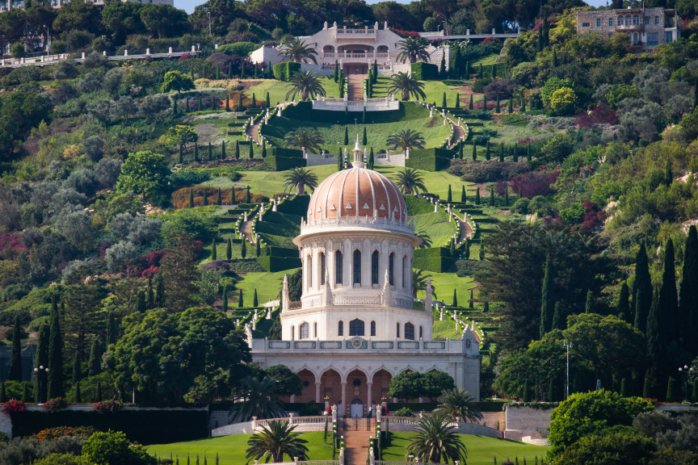

A view of some of the gardens:
https://www.youtube.com/watch?v=RGiXqusyrQ4&list=PLoO1RtuCx5K9UpsteA3_F2yRZI157d3DZ&index=5
Journeys of ‘Abdu’l-Bahá

In September 1910, ‘Abdu’l-Bahá left His home and traveled in the West with intervals of time in Egypt until December 1913. He had spent most of His life in prison and exile with His father; He entered prison as a youth and left it as an old man. He had no firsthand experience of Western culture; He did not know Western languages. Yet He set forth to carry His Father’s teachings to these lands. As described above, ‘Abdu’l-Bahá holds a unique and monumental station in the Bahá'í Faith. His journeys through Europe, the United States, and Canada were therefore of tremendous significance to the infant Bahá'í communities of those countries. (The religion had been introduced in the U.S. only in the 1890s.) As the travels of Bahá'u'lláh’s emissaries spread the Faith in the East, ‘Abdu’l-Bahá in His journeys purposely planted seeds of faith in the West. We continue to look to His actions and words as we strive to serve the community.

His call speaks loudly to our time: He firmly upheld racial equality in deeds as well as words. For example, He insisted on racially mixed gatherings in the heart of the Jim Crow era and notably in the nation’s capital, and He afforded Bahá'ís of African descent a place of honor at every opportunity in the spaces where He was the focus.

He briefly visited Philadelphia, where He spoke at Russell Conwell’s Baptist Temple, now part of Temple University; at the former Rittenhouse Hotel, 22nd and Chestnut Streets; at the Unitarian Church at 1518 West Girard Avenue, and at a private home (see below).

In His address at the Baptist Temple, ‘Abdu’l-Bahá spoke of “two pathways in the world of humanity: one the natural or materialistic, the other the religious or spiritual.” The full talk is:
https://www.bahai.org/library/authoritative-texts/abdul-baha/promulgation-universal-peace/13#752648070

Walking a Path of Service
Bahá'ís are convinced that the teachings of Bahá'u'lláh have much that is constructive to offer to society at large. Bahá'ís worldwide, along with others of like mind, are now engaged in a process of learning how best to serve humanity. This process is likened to walking a path of service. To progress along this path, individuals pursue a twofold moral purpose: to attend to their own spiritual and intellectual development and simultaneously seek to contribute to the betterment of society. Both aspects of the quest are essential. Through action, reflection, consultation, and study, those traveling the path of service assess their individual and collective progress and develop and refine the tools to assist in the twin purposes.

A Place of Pilgrimage in Philadelphia
(The Philadelphia Bahá'í Center, part of the virtual pilgrimage route, is a different site from the one described here. Please see the next section for information about the Bahá'í Center.)

Present-day Bahá'ís in the Philadelphia area remember ‘Abdu’l-Bahá’s visit to Philadelphia in June 1912 as an honor, a blessing, and a challenge to follow His example. In 2003, the Bahá'í community was able to purchase the modest brick rowhouse which was the only private home here in which He set foot. It was the home of the Revell family, prime movers in the early development of the Bahá'í Faith in this city. About fifty people pressed into its tiny space on June 10th, 1912, sitting in the foyer and on the staircase to hear Him talk happily about unity as He sat in a rocker by the front window. He visited every room in the house and rested for a while in the front bedroom, where He also received visitors.

Bahá'ís consider the Revell House to be the holiest place in Philadelphia. It has now been restored as closely as possible to its 1912 appearance. Although not an official place of pilgrimage like the sites in the Holy Land, it holds deep meaning for us. It is offered both to Bahá'ís and to the community at large as a place for prayer and meditation and as a focal point for future activities. (As the restoration was completed just before the start of the COVID-19 pandemic, activity has been limited so far.) The house is located at 1429 West Mayfield Street in Philadelphia and is open to visitors by appointment; contact Revellscheduler@gmail.com.

The Philadelphia Bahá'í Center
The Philadelphia Bahá'í Center at 2462 Bryn Mawr Avenue, Philadelphia, is home to worship, administrative activities, and community service. We are delighted to have a long relationship with Interfaith Philadelphia and to have hosted many interfaith gatherings each year.

The Center and its gardens are open to visitors by appointment (215-879-8866 or centerscheduler@gmail.com) and with safety procedures in place. Also, we warmly invite all to our devotional gathering on the second Sunday of each month at 2:00 PM. As of this writing, devotionals are in person; you may wish to call or email to verify this.

For a description of various activities at the Bahá'í Center, please see https://docs.google.com/document/d/17wAH9tQ-GbKemctKaPyypGyOJK0TKEa5/edit?usp=sharing&ouid=111980698480366206424&rtpof=true&sd=trueThe Philadelphia Bahá'í Center 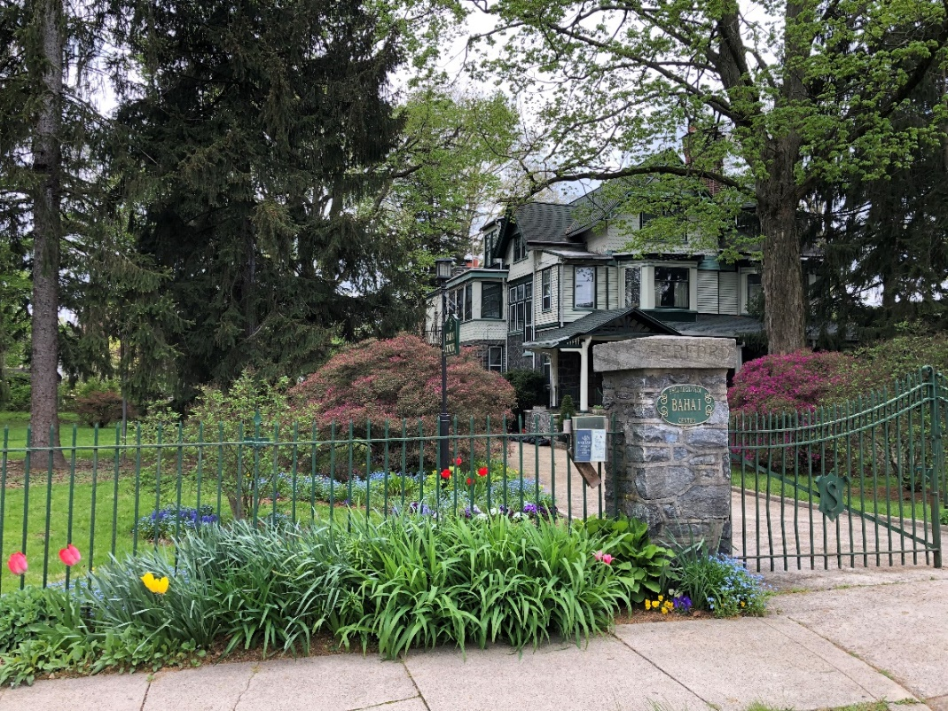

Gardens at the Philadelphia Bahá'í Center

